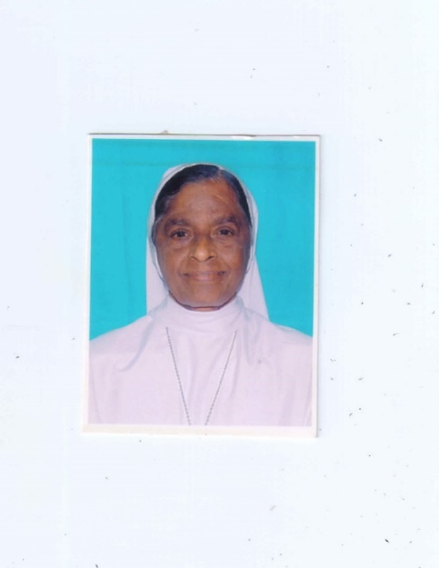 God Alone!

St. Ann’s Provincialate,

Melamiyur,

Chengalpatu

01.06.2018

***“O Sacred Heart,***

***Our home lies deep in thee.***

***On earth thou art an exile’s rest.***

***In heaven the glory of the Blest”.***

***F. Stanfield.***

Sr. Agostina Thomas, nurtured an ardent devotion to the Sacred Heart of Jesus even at an young age and was called to eternal rest in His divine heart on a Friday, the 25th of May 2018 at 6.35 A.M. Sister had a premonition of her ensuing end and prepared herself to meet it in peace and serenity. The Sisters of the three communities of Melamiyur were around her bed, praying the Mercy Rosary as her soul departed serenly.

On 6th May, 2018, Sister Agostina suffered hypertensive Cerebral Haemorrhage, that led to sudden onset of loss of consciousness and was rushed to the nearby hospital at Chengalpattu. Being a Sunday, the expert doctors were off duty, and was referred to Apollo super speciality hospital at Chennai. Sister was shifted there in an ambulance fitted with life support systems. The diagnosis revealed Left Basal Ganglia Haemorrhage and was admitted in Neuro ICU. Sister was a known case of Diabetes Mellitus, systemic Hypertension and CAD (Coronary Artery Disease). In the light of her history of illness and her advanced age, doctors could not give any hope of complete recovery but tried every possible means to regain her consciousness and restore her blood pressure to normalcy. Even after three days of intensive treatment, her condition remained the same without significant improvement. Sister was then shifted to SRM Medical College Hospital, where similar facilities are available and is closer to Chengalpattu. There Sister was admitted in the ICU and continued the treatment. As the days went by, the doctors found that her system was becoming unresponsive to the treatment and advised that, Sister Agostina could be shifted to the convent, where the sisters could attend to her freely, remain at her bedside and pray. Thus on 22nd May, Sister was shifted to her room at Madonna Villa on 22nd May, where she was given the anointing of the sick and was placed under the direct care of the Sisters, until the day of her departure to the heavenly abode.

Sr. Agostina (Mary Stella Josephine) was born to Yeddanapalli Rose Mary and Putti Thomas, in Pannur, in the Archdiocese of Madras – Mylapore, on 2nd June 1933. About her Religious Vocation Sister Agostina says, “I do not know where, when and how I heard the Call, but once I heard it, I could not resist it”. She entered the Novitiate at Secunderabad on 20th May 1952, made her first profession in 1955 and Perpetual Vows on 1st January 1961. Noticing her high mental calibre, enterprising spirit and zeal for service, she was selected to pursue her M.B.B.S. course and secured admission in the prestigious CMC (Christian Medical College) Vellore in 1958. After successfully completing her studies in Medicine, in 1961 Sister was appointed as doctor in – charge at St. Ann’s Hospital, Fatimanagar. In 1965 she was sent to Boston, in United States to complete her Post Graduation in Medicine (MD) with specialization in general surgery. After her return to India in 1970, Sister continued her healing ministry as a full-fledged doctor at St. Ann’s, Fatimanagar till 1986. In 1987, at the request of the CBCI (Catholic Bishop’s Conference of India) rendered service at St. John’s Medical College Hospital, Bangalore and remained there as HOD (Head of the Department) of fertility centre 1995. When the proposal to start Asha Hospital at Gollapudi was cleared, in 1996, Sr. Agostina, was sent there as doctor in-charge to pioneer the work. With the support of a team of expert doctors and sister nurses, Sr. Agostina worked hard, utilising her medical skill and efficiency to its optimum level and developed the Unit into a full-fledged hospital with a well equipped operation theatre and laboratory and rendered her service as doctor and surgeon till 2010. In 2011, as her health began to deteriorate, Sr. Agostina was transferred to Madonna Villa, Melamiyur for rest and treatment.

In the medical field, Sr. Agostina was well known for her surgical skills and correct diagnosis. She was always happy to share her knowledge and expertise with others and guided the sister nurses to work in the healing ministry with perfection and dedication. During the 1980s and 90s, when female foeticides and infanticides were common, Sr. Agostina became a crusader, condemning these practices which were against the teachings of Catholic Church, by propagating pro-life movement, through publications, conducting seminars and camps. She also took up extensive awareness programme on HIV/AIDS, published two books, “Walk along with me in an AIDS free world” and “Natural Method of Fertility Regulations”. Teaching in Formation houses on topics like: Sexuality in the context of consecrated virginity” and conducting medical check-up for formees were part of her mission, which were voluntarily done with care and commitment.

Sr. Agostina was a person of deep faith and filial trust in the Providence of God. She was open and spontaneous in her dealings, specially kind and considerate towards the needy. Anyone who sought help from her, material or spiritual, never went empty handed but with a comforting smile. In her Bio-data file the concluding verse in her own handwriting is, “How many years I would need to praise, bless and thank Him for all these special favours to me”. In answer, God granted her 63 years to love and serve Him in His vineyard. Her younger sister, Sr. Adelphine, who is presently at St. Antony’s Convent, Gollapudi, on hearing the sad news was greatly grieved and remarked, “Here was a beautiful life with full of beautiful moments. When she served food to someone hungry, gave a drink to someone thirsty, when she clothed a poor person, welcomed a stranger with a smile, tended and healed a sick sister or brother, she did all these to Jesus Himself”.

The funeral Mass was officiated by Rev. Fr. Arul Raj, former Vicar General of Chengalpattu Diocese and con-celebrated by many priests from Chennai and the nearby parishes. There was a large throng of Religious Sisters, family members and lay brethren who participated in the Holy Mass. In his homily, Fr. Arul Raj remarked that a consecrated medical practitioner brings comfort and courage to the sick through the healing touch, just as Jesus stretched forth His hand to touch and heal many. Healing brings joy and smile on the faces of the afflicted and this is an offering pleasing to God and so Sr. Agostina was rewarded with a happy death.

Sr. Ursula Saminini, in her introductory before the Holy Mass said, “Today is a day for memories, a day in which we share some time together to pay our last respect and to bid a loving farewell to a wonderful religious sister, she was a woman, who bravely, courageously and fearlessly walked the life’s journey”.

At this moment, we express our deepest sympathy to our dearest Sister Adelphine, who suffers an irreparable loss at the departure of her beloved Sister. We also extend our heartfelt sympathies to her brothers Mr. Joe, Mr. Alphonse and her family members and relatives, who were present for the funeral Mass.

I wish to convey my sincere thanks to Sr. Fatima Philip, the animator of Madona Villa community and Sr. Sathya, the sister nurse, who took care of Sr. Agostina during her illness. In a special way I thank Sr. Nirmala Joris, the Provincial Councillor, who generously rendered every possible support, in allotting sisters to stay in the hospital round the clock for 18 days and making all the necessary arrangements for the funeral. I am deeply obliged to Sr. Pushpa Kumari, Sr. Fatima Arulraj and all the sisters of the nearby communities especially St. Mary’s Chengalpattu and those who came from far away places, for their support and closeness that strengthened us in these painful moments. I thank Sister Jesintha Mariappa, the Provincial Superior of Central Province and the Sisters from Fatimanagar Hospital who were present for the funeral.

After the Holy Mass, the mortal remains of Sr. Agostina was led in procession to the Sisters’ Cemetery and was laid to rest at 12.15 P.M. on Saturday.

As we continue to offer our supplications before the Lord, on behalf of our dearest Sister, let us pray that her soul may find infinite joy in the presence of the Almighty, whom she loved and served faithfully to the end.

May God reward her with eternal life in heaven.

Yours lovingly,

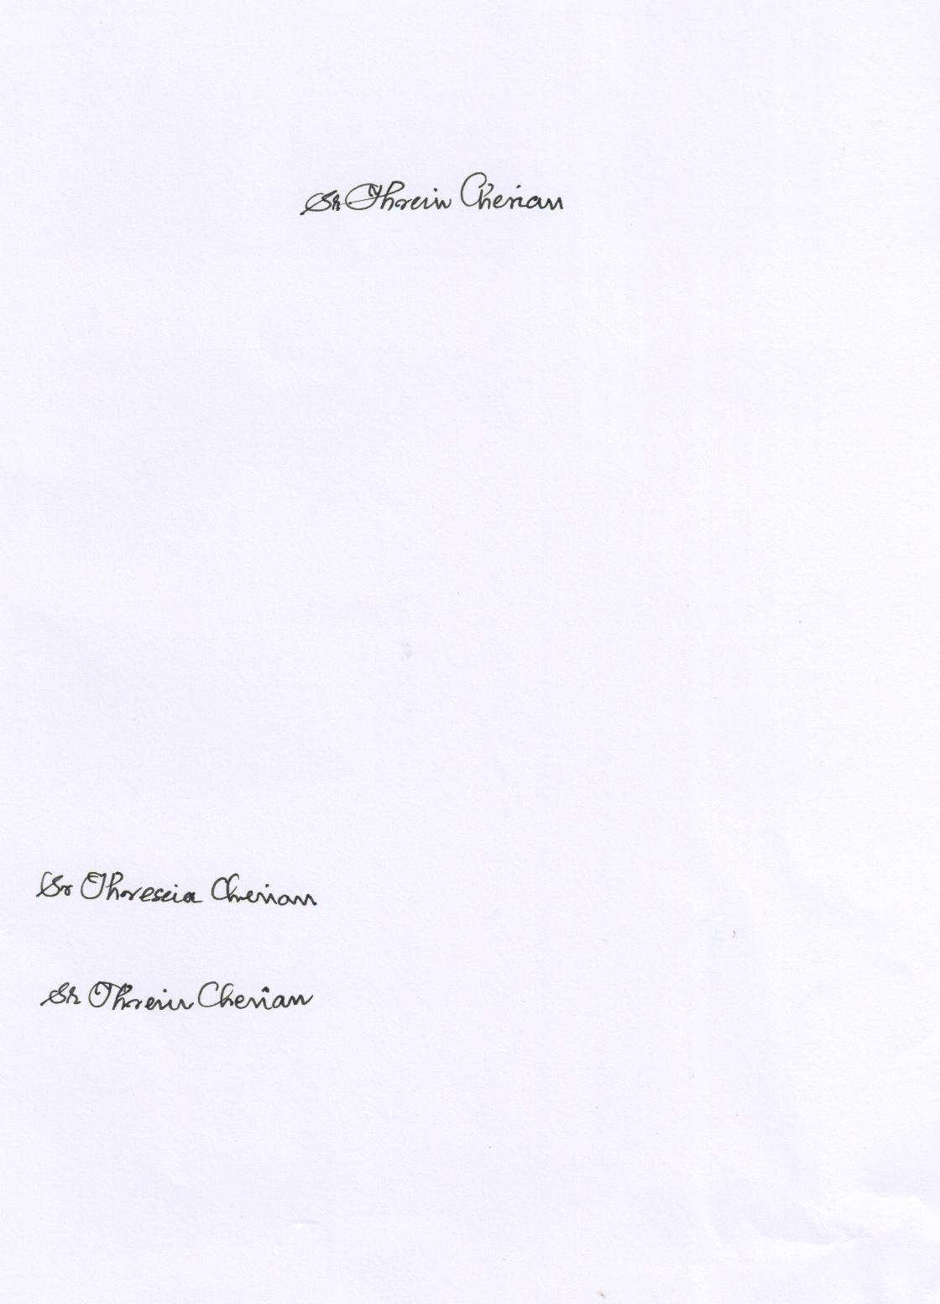

Sr. Theresa Cherian,

The Provincial Superior